**ML Assignment1**

**1 Python Machine Learning Stack (Anaconda)**

You will use Python in this course. In order to prepare for future assignments and the final project, you will be asked to install Python and its useful packages via Anaconda. Anaconda is a high performance distribution of Python and R and includes over 100 of the most popular Python, R and Scala packages for data science. More information on Anaconda can be found here.

Follow these instructions to install Anaconda.

Make sure you confirm that Anaconda is installed and working by opening a terminal window and running the command

>> conda list If Anaconda is installed and working, this will display a list of installed packages and their versions. You can also confirm that Anaconda is installed and working by opening a terminal window and running the command

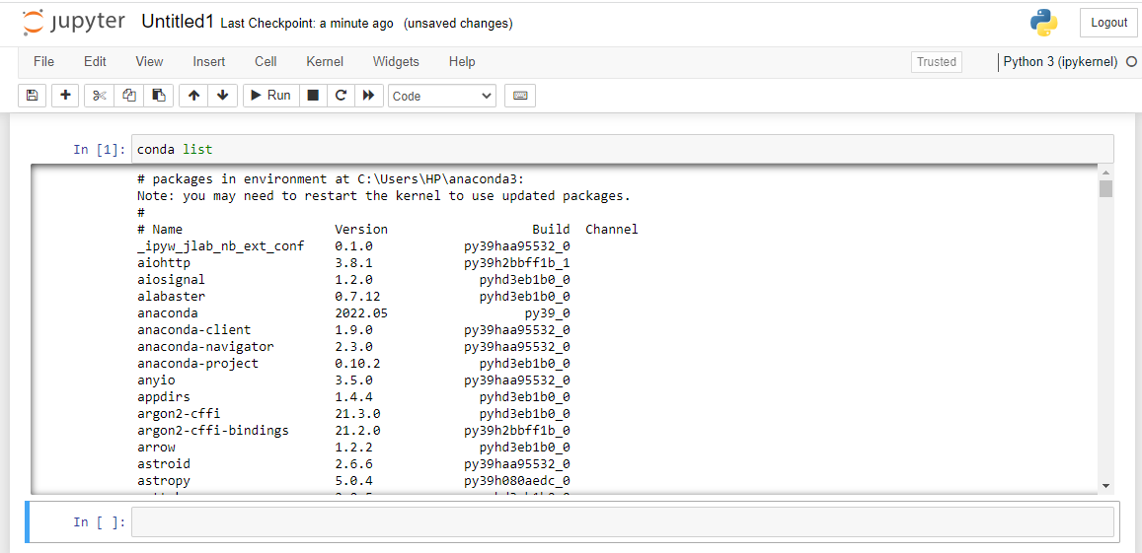

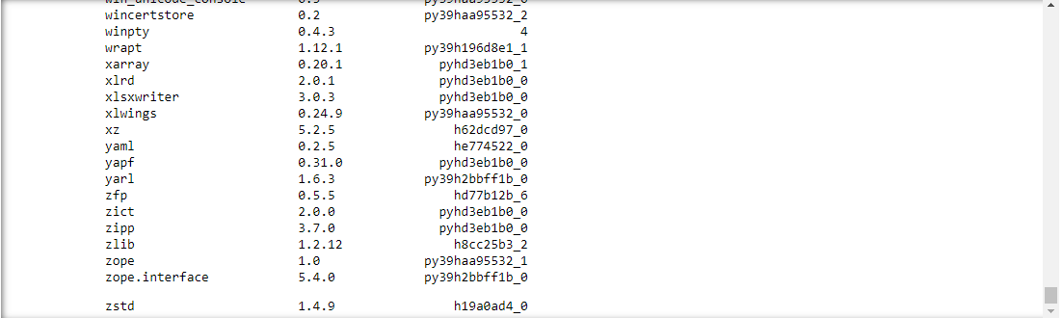

>> python

to run the Python shell. If Anaconda is installed and working, the version information it displays when it starts up will include ”Continuum Analytics, Inc.”. Use the command

>> quit()

to exit the Python shell. Read this Cheat sheet to learn how to use the ”conda” command.

1.1 Task 1

In your terminal, run

>> conda info

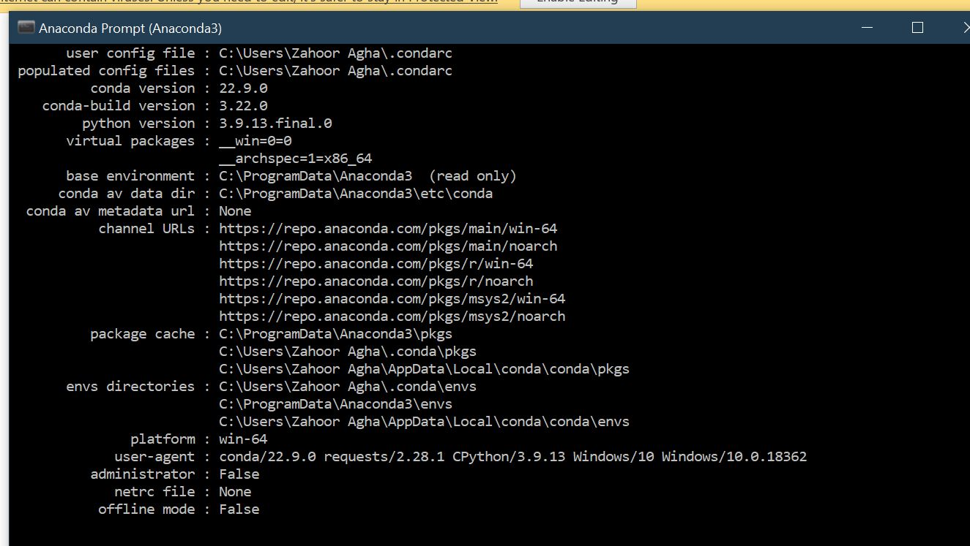

and paste the result into your report.

2 Interactive Terminal (IPython/Jupyter)

IPython/Jupyter is an interactive computational environment in which you can combine code execution, rich text, mathematics, plots, and rich media. Follow this IPython Tutorial and Jupyter Documentation to get up and running on IPython/Jupyter. For more on IPython/Jupyter, check out this great Gallery of Jupyter Notebooks.

3 Plotting (MatPlotLib/PyPlot)

Matplotlib is the main plotting library for Python and is capable of very powerful publication quality graphics. Check out this Matplotlib Gallery if you would like to learn more about plotting using Matplotlib. Pyplot is a library within Matplotlib that is there to ease the transition from MATLAB to Python. It has a collection of MATLAB-like functions that makes plotting in Python as easy as in MATLAB. Please read through the following Pyplot Tutorial.

3.1 Task 2

Run the following script in IPython and paste the figure created by the script into your report import matplotlib.pyplot as plt plt.plot([1,2,3,4], [1,2,7,14]) plt.axis([0, 6, 0, 20]) plt.show()

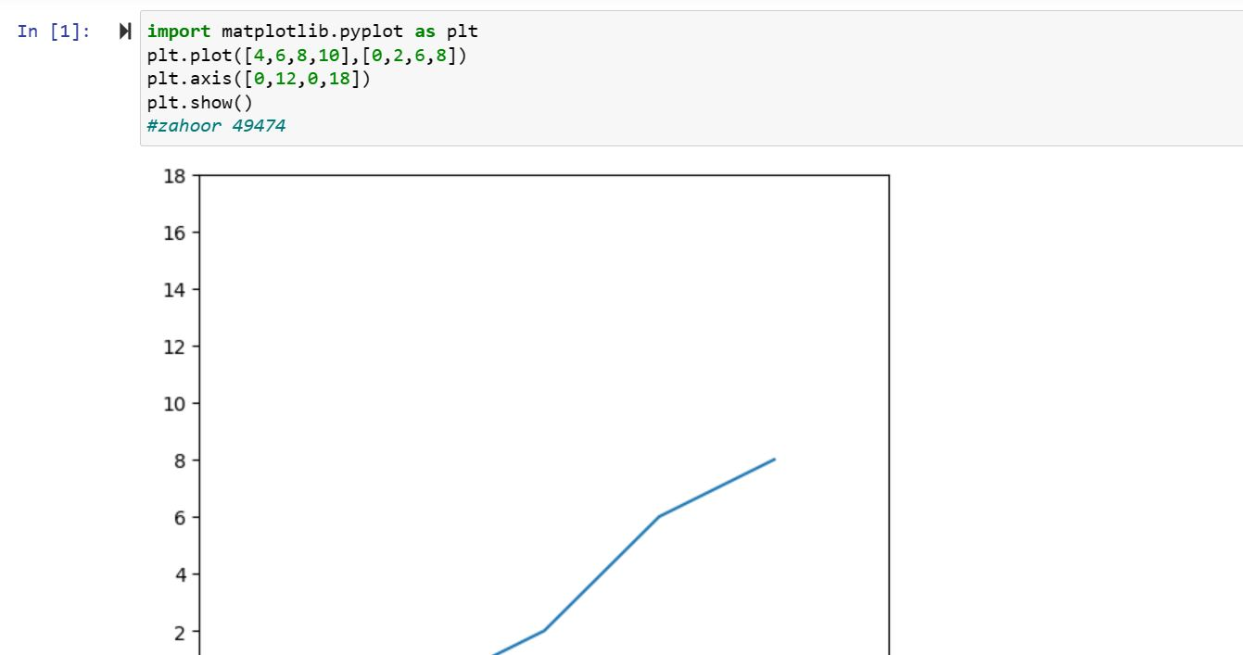

3.2 Task 3

Use Matplotlib to create a figure of your choice in IPython. Paste your code and figure into your report

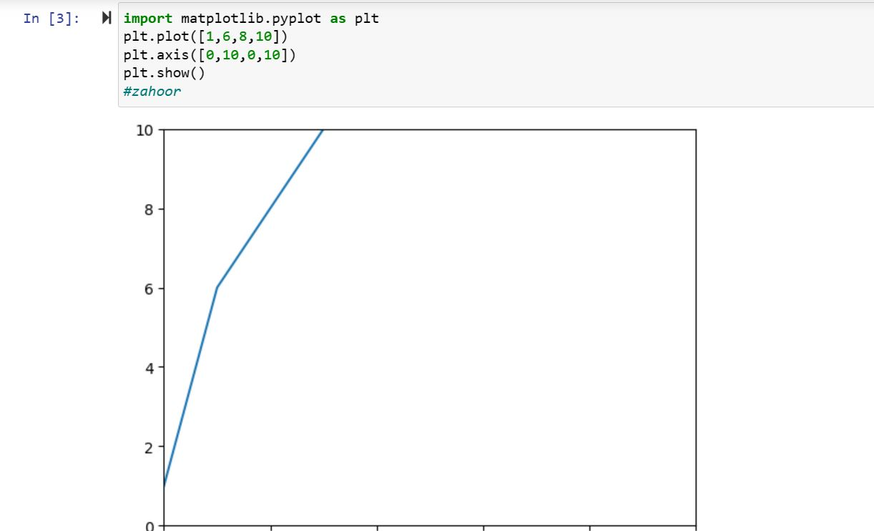

4 Version Control System (BitBucket/GitHub

When you are working on a big project with your team, managing the changes in your code will be challenging. Version control systems (VCS) like Git help streamline this process. Read this article on why VCS is necessary. Bitbucket and Github are two commonly used web-based hosting services for projects that use Git version control systems. In this course, you will use Github.

2

4.1 task 4

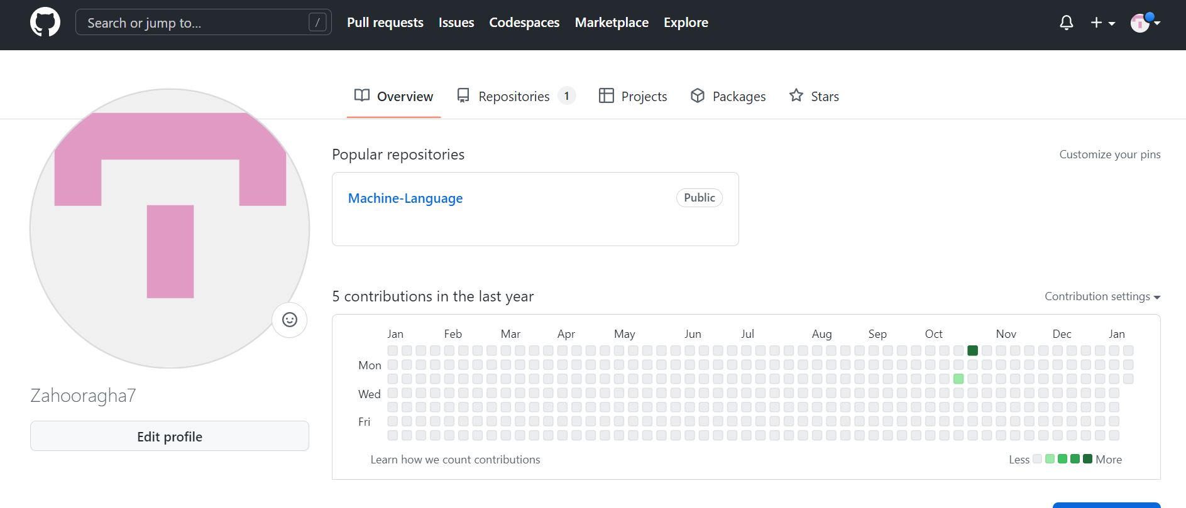

register for a student account here for free private repository access for future projects and go through these tutorials. insert a screenshot of your user page in github in your report.

5 Submission Instructions

Every student must submit their work in PDF format, providing intermediate and final results as well as any necessary code. Submit your homework via EMAIL.

6 Collaboration Policy

Collaboration both inside and outside class is encouraged. You may talk to other students for general ideas and concepts, but individual write-ups must be done independently.

7 Plagiarism

Plagiarism of any form will not be tolerated. you will get a NEGATIVE SCORE. this includes copied home works. You are expected to credit all sources explicitly

3